Flashcard Study Web Application

Product Backlog Document
Team: Agile Addicts
Course: COSC 625
Due: March 29, 2026
Members: Chidi Azubike, Richard Baldwin, Frits Buningh, Andrew Naylor

Dependency / Blocker Notes
Understanding these blockers will help the team sequence work correctly across Thursday–Sunday.
Blocked Task | Blocked By | Who Is Waiting
Sprint 1 selection (Section 4) | Story refinement and sub-story breakdown (Section 1) | Richard
Scrum board Sprint 1 column | Sprint 1 selection finalized | Richard
Fibonacci group estimates (Section 2) | All sub-story breakdowns must exist | Everyone (group exercise)
UI mockups — session/flip screens (Section 5) | US-6 sub-stories defined | Chidi
UI mockups — deck/card screens (Section 5) | US-3, US-4, US-5 sub-stories defined | Frits
Textbook connection (Section 7) | Story structure stable | Andrew
Pre/postconditions for sub-stories (Section 3) | Sub-story breakdown complete | Andrew
Critical path: Andrew's story refinement must be done first. Everything else flows from it.

1. User Story Refinement
Assigned: Andrew Naylor (Writing Lead)
Refine user stories US-1 through US-7 from the SRS. Break any stories too large for a single sprint into sub-stories. Incorporate any feedback received. Each story should be small enough to deliver tangible value within one sprint.

US-1: Register
1.1 - As a new user I want to enter my name, email, and password, so that I can create an account.
1.2 - As a system, I want to securely store user credentials so that accounts can be used later for login.
1.3 - As a user, I want feedback on invalid input so that I can correct mistakes like duplicate emails or weak passwords.

US-2: Login
2.1 - As a user I want to enter my login credentials so that i can attempt to access my account
2.2 - As a system, I want to verify user credentials so that only valid users can log in
2.3 - As a user, I want a session to be create after I log in so that i stay authenticated while using the system
2.4 - As a user, I want to be notified if my login fails so that I can retry

US-3: Create Deck
3.1 - As a user, I want to create a deck with a title so that I can start organizing flashcards
3.2 - As a user, I want to add a description to a deck so that I can better understand it purpose
3.3 - As a user, I want to tag decks so that I can categorize them
3.4 - As a user, I want to set a deck as public or private so that I can control visibility.

US-4: Update Deck
4.1 - As a user , I want to edit a decks title and description so that I can keep my content updated
4.2 - As a user, I want to delete a deck so that I can remove decks I no longer need.
4.3 - As a user, I want to update deck tags so that I can reorganize my decks

US-5: Create/Edit Flashcard
5.1 - As a user, I want to create a flash card with a front and a back to that I can study the question and have the answer immediately available
5.2 - As a user, I want to edit flashcards so that I can refine my study material
5.3 - As a system, i want to require both front and back fields so that all cards are complete
5.4 - As a user, I want to upload images to flashcards so that I can include visual context
5.5 - As a system, I want to enforce file type and size limits so that uploads remain valid
5.6 - As a user, I want to preview my flashcard before saving so that I can check formatting

US-6: Start Study Session
6.1 - As a user, I want to start a study session so that I can review a selected deck
6.2 - As a uses, I want to view flash cards one at a time so that I can focus on each question
6.3 - As a user, I want to flip a flashcard so that I can reveal the answer
6.4 - As a user , I want to mark answers as correct or incorrect so that my performance is tracked
6.5 - As a user, I want to see a summary after the session so that I can evaluate how I did
6.6 - As a system, I want to adjust card frequency based on performance so that studying becomes more effective."

US-7: Track Progress
7.1 - As a system, I want to store study session results so that progress can be tracked over time
7.2 - As a user, I want to view my accuracy so that I can measure improvement
7.3 - As a user, I want to view past sessions so that I can see trends in my performance
7.4 - As a user, I want to track my study streak so that I stay consistent

2. Story Size Estimates (Fibonacci)
Assigned: All Members (GROUP EXERCISE — finalized at Thursday meeting)
Each story and sub-story receives a Fibonacci estimate (1, 2, 3, 5, 8, 13…) reflecting effort, complexity, and time. Time estimates in minutes/hours provided per sub-story. Parent story time = sum of sub-story times.
Primary drafts before meeting:
- Andrew: US-3 (Create Deck), US-7 (Track Progress)
- Chidi: US-1 (Register/Auth), US-6 (Study Session)
- Frits: US-4 (Update Deck), US-5 (Create/Edit Flashcard)
- Richard: US-2 (Login), overall cumulative total
Story | Sub-Story | Fibonacci Points | Est. Time (min) | Notes
US-1 | Register | 4 | 120 min
 | 1.1 create account | 2 | 60 min
 | 1.2 store user cred | 1 | 30 min | This may just be a browser thing
 | 1.3 invalid notif specifics | 1 | 30 min
US-2 | Login | 4 | 120 min
 | 2.1 - user login | 1 | 30 min
 | 2.2 - verify creds | 1 | 30 min
 | 2.3 - session | 1 | 30 min
 | 2.4 - login fail notify | 1 | 30 min
US-3 | Create Deck | 5 | 135 min
 | 3.1 Title deck | 1 | 30 min
 | 3.2 Deck description | 1 | 30 min
 | 3.3 Tag deck | 1 | 30 min
 | 3.4 Set Deck as Public or private | 2 | 45 min
US – 4 | Update Deck | 8 | 330 min
 | 4.1 Edit Deck | 2 | 90 min
 | 4.2 Delete Deck | 3 | 120 min
 | 4.3 Update Tags | 3 | 120 min
US-5 | Create/Edit Flashcard | 16 | 730 min
 | 5.1 Create Flashcard (front & Back) | 3 | 150 min
 | 5.2 Edit Flashcard | 2 | 120 min
 | 5.3 Front & Back fields (validation logic) | 1 | 60 min
 | 5.4 Upload Images | 5 | 240 min
 | 5.5 File Type & Size Validation | 2 | 90 min
 | 5.6 Preview Flashcard | 3 | 150 min
US-6 | Start Study Session | 13 | 465 min
 | 6.1 - start a study session | 3 | 135 min
 | 6.2 - view flash cards one at a time | 2 | 60 min
 | 6.3 - flip a flashcard | 2 | 60 min
 | 6.4 - mark answers as correct or incorrect s | 2 | 60 min
 | 6.5 - session summary | 1 | 30 min
 | 6.6 - adjust card frequency based on performance | 3 | 120 min
US-7 | Track Progress | 7 | 210 min
 | 7.1 store study sessions | 2 | 60 min
 | 7.2 View Answer Accuracy | 2 | 60 min
 | 7.3 view past sessions | 2 | 60 min
 | 7.4 track study streak | 1 | 30 min
Total |  | 57 | 2190 min

3. Pre- and Postconditions
US-1: Register
1.1 - As a new user, I want to enter my name, email, and password so that I can create an account.
Precondition: The user is on the registration page and does not have an account.
Postcondition: User input is captured and ready for validation.
1.2 - As a system, I want to securely store user credentials so that accounts can be used later for login.
Precondition: Valid registration data has been submitted.
Postcondition: The user account is stored in the database with a hashed password.
1.3 - As a user, I want feedback on invalid input so that I can correct mistakes like duplicate emails or weak passwords.
Precondition: The user submits invalid or incomplete data.
Postcondition: The system displays errors and prevents account creation.
US-2: Login
2.1 - As a user, I want to enter my login credentials so that I can attempt to access my account.
Precondition: The user has an existing account and is on the login page.
Postcondition: Credentials are submitted for verification.
2.2 - As a system, I want to verify user credentials so that only valid users can log in.
Precondition: Credentials have been submitted.
Postcondition: The system determines if authentication is successful.
2.3 - As a user, I want a session to be created after I log in so that I stay authenticated while using the system.
Precondition: Credentials are verified successfully.
Postcondition: An active session is created and the user is redirected to their dashboard.
2.4 - As a user, I want to be notified if my login fails so that I can retry.
Precondition: Invalid credentials are submitted.
Postcondition: An error message is shown and no session is created.
US-3: Create Deck
3.1 - As a user, I want to create a deck with a title so that I can start organizing flashcards.
Precondition: The user is logged in.
Postcondition: A new deck is created and linked to the user.
3.2 - As a user, I want to add a description to a deck so that I can better understand its purpose.
Precondition: A deck is being created or edited.
Postcondition: The description is stored with the deck.
3.3 - As a user, I want to tag decks so that I can categorize them.
Precondition: A deck exists.
Postcondition: Tags are stored and linked to the deck.
3.4 - As a user, I want to set a deck as public or private so that I can control visibility.
Precondition: A deck exists.
Postcondition: Visibility settings are saved and enforced.
US-4: Update Deck
4.1 - As a user, I want to edit a deck’s title and description so that I can keep my content updated.
Precondition: The user is logged in and owns the deck.
Postcondition: Updated deck data is saved.
4.2 - As a user, I want to delete a deck so that I can remove decks I no longer need.
Precondition: The user is logged in and owns the deck.
Postcondition: The deck and its flashcards are removed from the database.
4.3 - As a user, I want to update deck tags so that I can reorganize my decks.
Precondition: The user is logged in and the deck exists.
Postcondition: Updated tags are saved.
US-5: Create/Edit Flashcard
5.1 - As a user, I want to create a flashcard with a front and a back so that I can study the question and have the answer immediately available.
Precondition: The user is logged in and a deck exists.
Postcondition: A flashcard is created and linked to the deck.
5.2 - As a user, I want to edit flashcards so that I can refine my study material.
Precondition: The user is logged in and the flashcard exists.
Postcondition: Updated flashcard content is saved.
5.3 - As a system, I want to require both front and back fields so that all cards are complete.
Precondition: A flashcard is being created or edited.
Postcondition: The system prevents saving if required fields are missing.
5.4 - As a user, I want to upload images to flashcards so that I can include visual context.
Precondition: The user is creating or editing a flashcard.
Postcondition: The image is uploaded and linked to the flashcard.
5.5 - As a system, I want to enforce file type and size limits so that uploads remain valid.
Precondition: An image is submitted.
Postcondition: Invalid files are rejected and valid files are stored.
5.6 - As a user, I want to preview my flashcard before saving so that I can check formatting.
Precondition: The user has entered flashcard content.
Postcondition: A preview is displayed based on current input.
US-6: Start Study Session
6.1 - As a user, I want to start a study session so that I can review a selected deck.
Precondition: The user is logged in and the deck has at least one flashcard.
Postcondition: A study session is started and cards are loaded.
6.2 - As a user, I want to view flashcards one at a time so that I can focus on each question.
Precondition: A study session is active.
Postcondition: Flashcards are displayed sequentially.
6.3 - As a user, I want to flip a flashcard so that I can reveal the answer.
Precondition: A flashcard is displayed.
Postcondition: The answer side is shown.
6.4 - As a user, I want to mark answers as correct or incorrect so that my performance is tracked.
Precondition: A flashcard has been viewed.
Postcondition: The user’s response is recorded.
6.5 - As a user, I want to see a summary after the session so that I can evaluate how I did.
Precondition: The session has ended.
Postcondition: A summary of results is displayed.
6.6 - As a system, I want to adjust card frequency based on performance so that studying becomes more effective.
Precondition: User responses have been recorded.
Postcondition: Future card ordering is adjusted.
US-7: Track Progress
7.1 - As a system, I want to store study session results so that progress can be tracked over time.
Precondition: A study session has been completed.
Postcondition: Session data is saved in the database.
7.2 - As a user, I want to view my accuracy so that I can measure improvement.
Precondition: At least one session exists.
Postcondition: Accuracy metrics are calculated and displayed.
7.3 - As a user, I want to view past sessions so that I can see trends in my performance.
Precondition: Session history exists.
Postcondition: A list of past sessions is displayed.
7.4 - As a user, I want to track my study streak so that I stay consistent.
Precondition: The user has completed sessions across multiple days.
Postcondition: A streak value is calculated and displayed.

4. Sprint 1 Plan
Assigned: Richard Baldwin (Organization Lead)
Select a subset of stories (~1/3 of backlog) for Sprint 1. Document dependencies. Define the Sprint Goal clearly. Sprint Goal: By the end of Sprint 1, a user can register, log in, create a deck, and add or edit flashcards within that deck.
Story | Sub-Stories | Points | Rationale | Dependencies
US-1: Register | 1.1, 1.2, 1.3 | 4 | Foundation — no authenticated features work without this | None
US-2: Login | 2.1, 2.2, 2.3, 2.4 | 4 | Gates all user-facing functionality | US-1
US-3: Create Deck | 3.1, 3.2, 3.3, 3.4 | 5 | First real user-facing feature post-auth | US-2
US-5: Create/Edit Flashcard (core) | 5.1, 5.2, 5.3 | 6 | Core card CRUD; image upload deferred to Sprint 2 | US-3
Sprint 1 Total: 19 points

Sprint Distribution (4 members, 3 × 2-week sprints)
Sprint | Stories | Points | Notes
Sprint 1 | US-1, US-2, US-3, US-5 (5.1–5.3) | 19 | Auth + core content creation; delivers a demonstrable vertical slice
Sprint 2 | US-4, US-5 (5.4–5.6), US-6 | 27 | Deck management, image support, full study session
Sprint 3 | US-7, polish, stretch goals | 11+ | Progress tracking, UI refinement, integration buffer

Dependency Notes
Story | Depends On | Blocks
US-1 Register | — | US-2
US-2 Login | US-1 | US-3, US-4, US-5, US-6, US-7
US-3 Create Deck | US-2 | US-4, US-5
US-4 Update Deck | US-3 | —
US-5 Create/Edit Flashcard | US-3 | US-6
US-6 Study Session | US-5 | US-7
US-7 Track Progress | US-6 | —
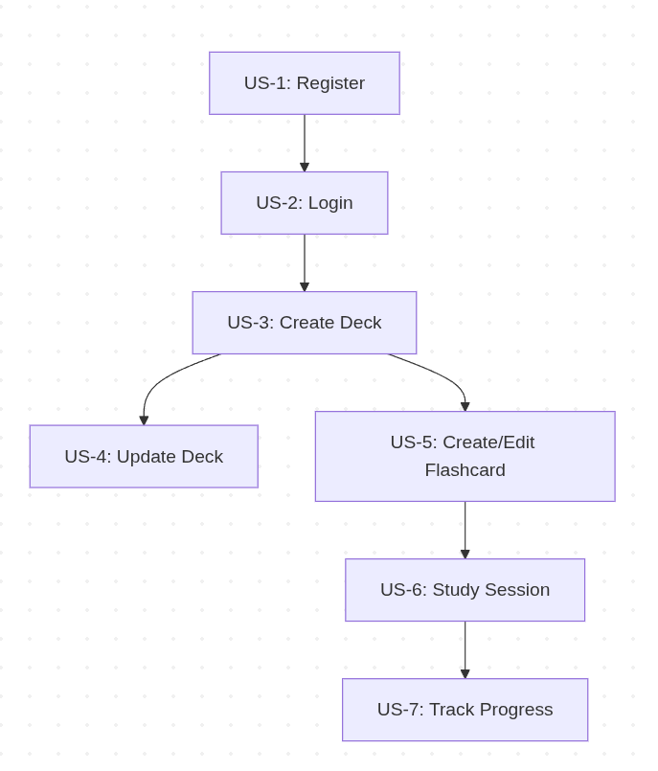

5. UI Design
Assigned: Chidi Azubike (Programming Lead) and Frits Buningh (DB Lead)
Professional mockups using Figma or Proto.io. Each mockup should correspond to one or more user stories and illustrate system interaction.
- Chidi: Study Session screen, Flashcard Flip UI
- Frits: Deck Management screen, Flashcard Creation screen
- Shared: Login/Registration screen
Proto.io Link: https://pr.to/28RH1J/
- US-1: Registration
This interface allows first time users to register before using the application. Registration is complete after user fills the required fields on the screen and clicks the Register button

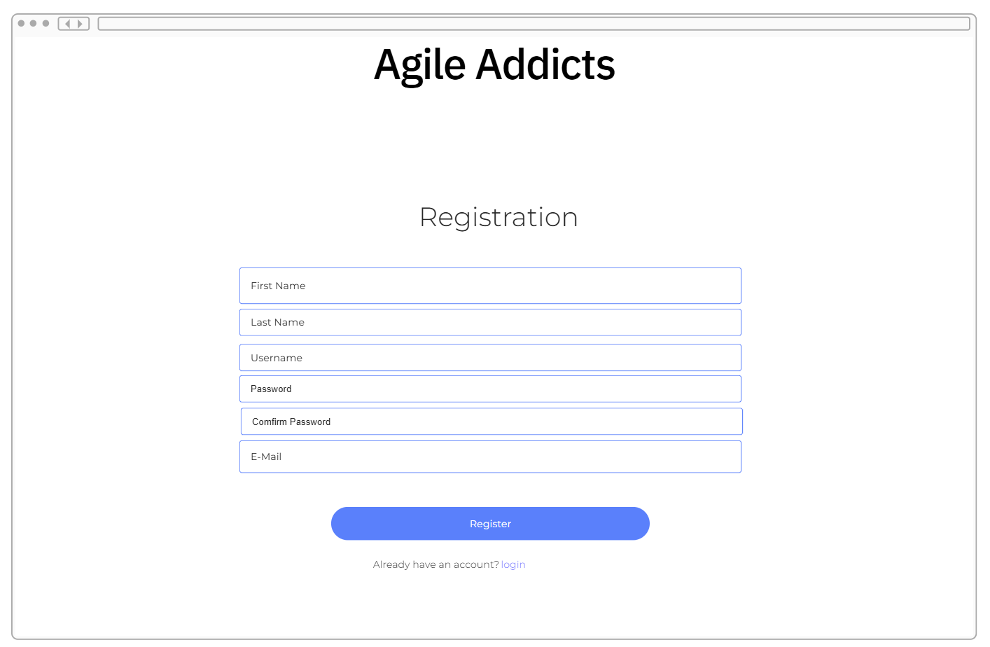

- US-2: Login
This interface allows users to login to the application by entering an email, a password and clicking the login button.

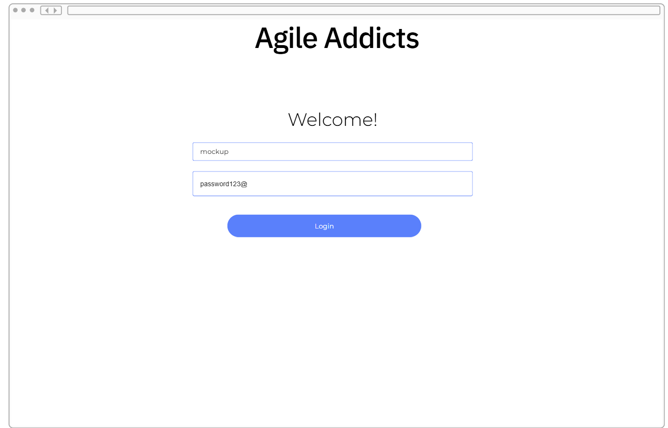

Flashcard Management Screen
- US-3: Create Deck
This interface allows authenticated users to create a Deck card, if none existed. Newly created decks are visible on the Deck list. Users can Edit/Update any of the decks on the list by clicking the Edit Deck/Update Deck button.
When a user clicks on the Edit Deck/Update Deck button, the application navigates to the Update Deck Screen.
Users can also select to create or edit a flash card by selecting a deck and clicking on the Create/Edit Flashcard button.
When a user clicks on the Create/Edit Flashcard button, the application navigates to the Create/Edit Flashcard screen.

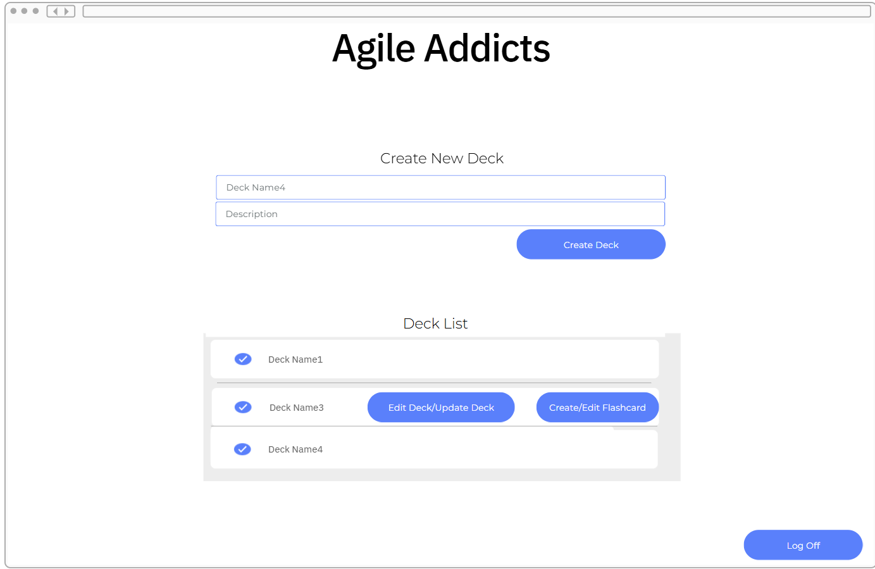
- US-4: Update Deck
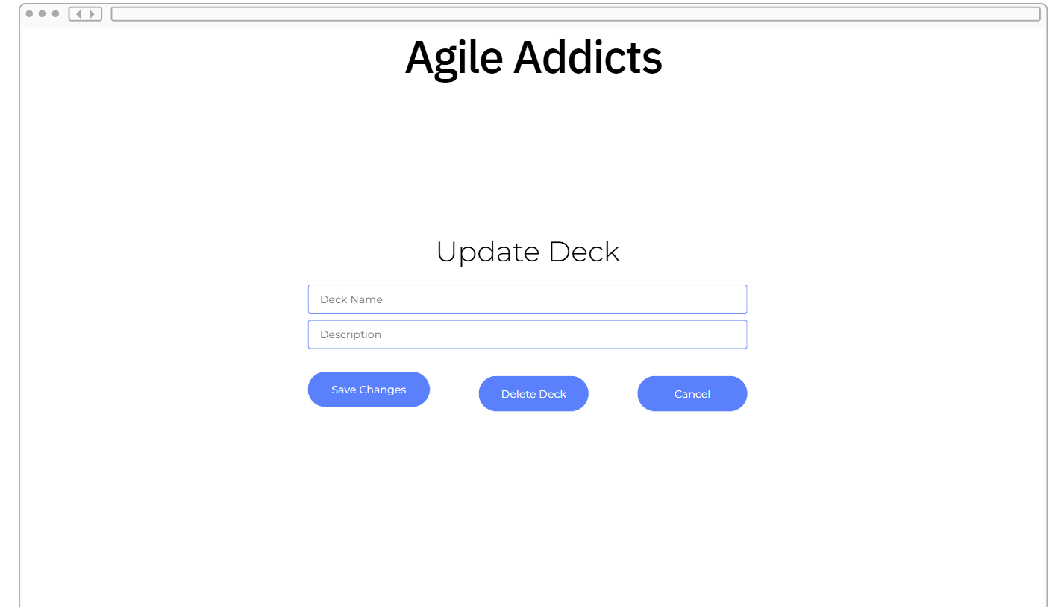
This interface allows users to update a selected deck from a previous interface.
Users can change the deck name or deck description and click the Save Changes button.

Users can delete the deck by clicking the Delete Deck button.

- US-5: Create/Edit Flashcard
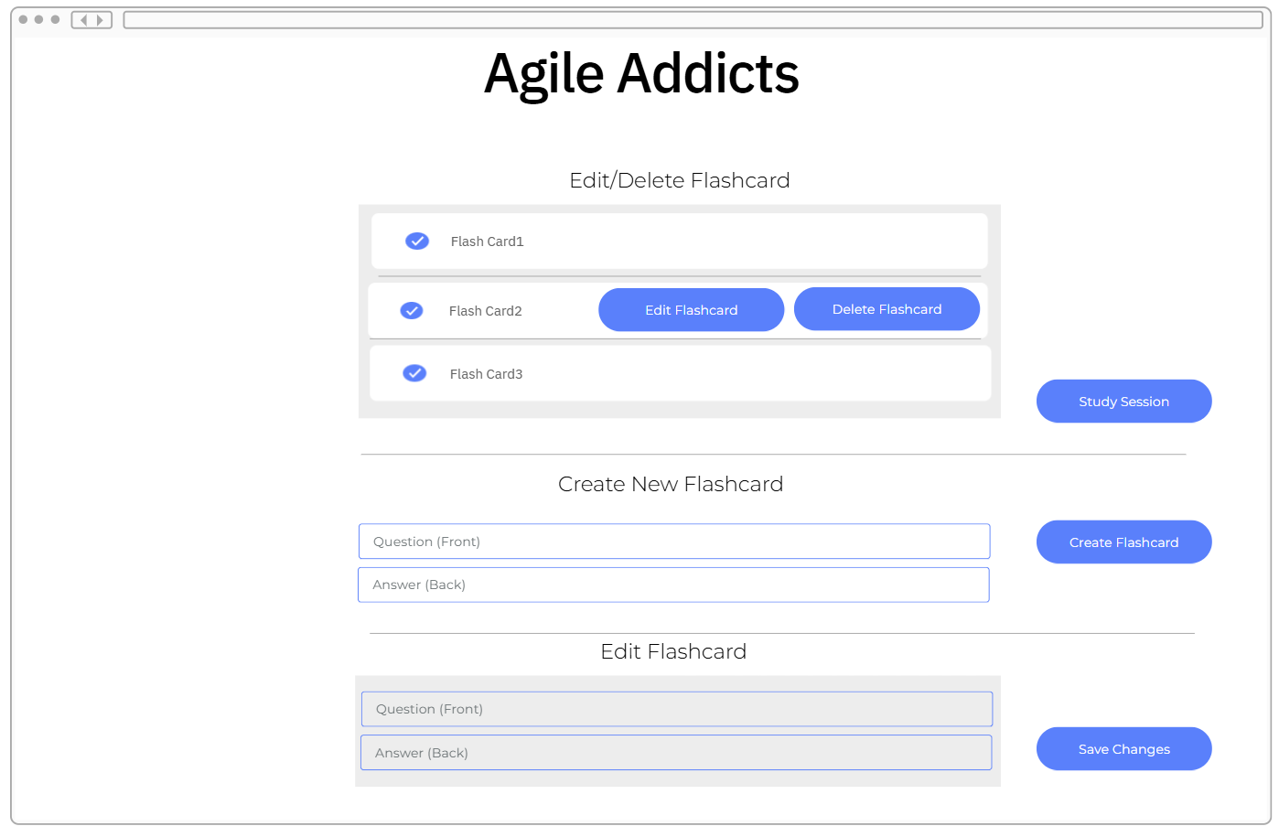
This interface allows users to create/edit a flashcard.
When a user clicks on the Edit Flashcard button on the Flashcard list(s), an Edit Flashcard section is displayed, and user can change the Question/Answer field and click the Save Changes button for the changes to be reflected.
User can create a new flashcard by going to the Create New Flashcard section and adding values in the Question/Answer Field and clicking the Create Flashcard button for a new flashcard to be created.
Users can navigate to the study section interface by clicking on the Study Session button.
- US-6: Study Session
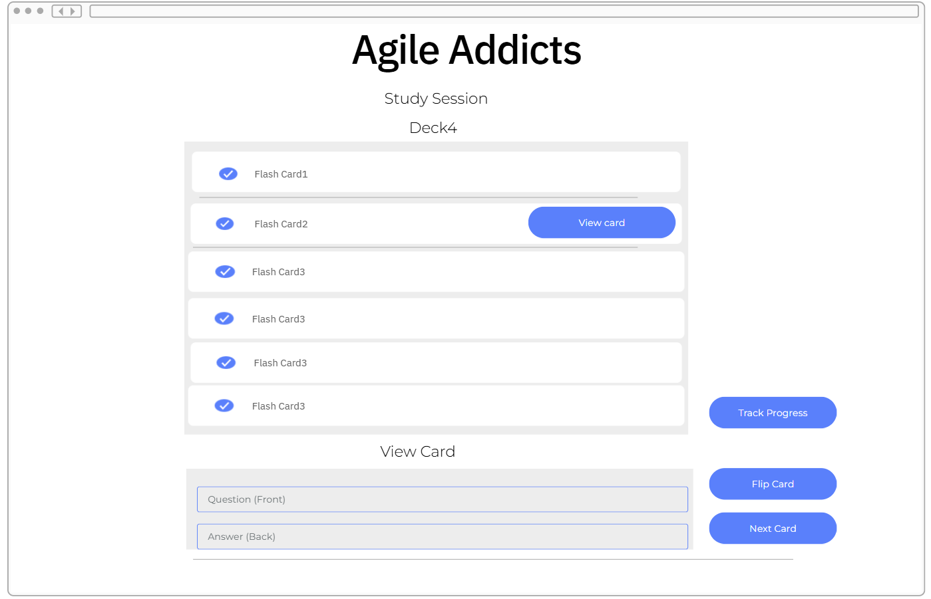
This interface allows users to select a flashcard from the list, and the card information is displayed on the View Card section.
Users can flip the card by clicking the flip button to see the answers.
Users can track progress by clicking the Track progress button
Users can also click the next card button to see the next card.
- US-7: Track Progress
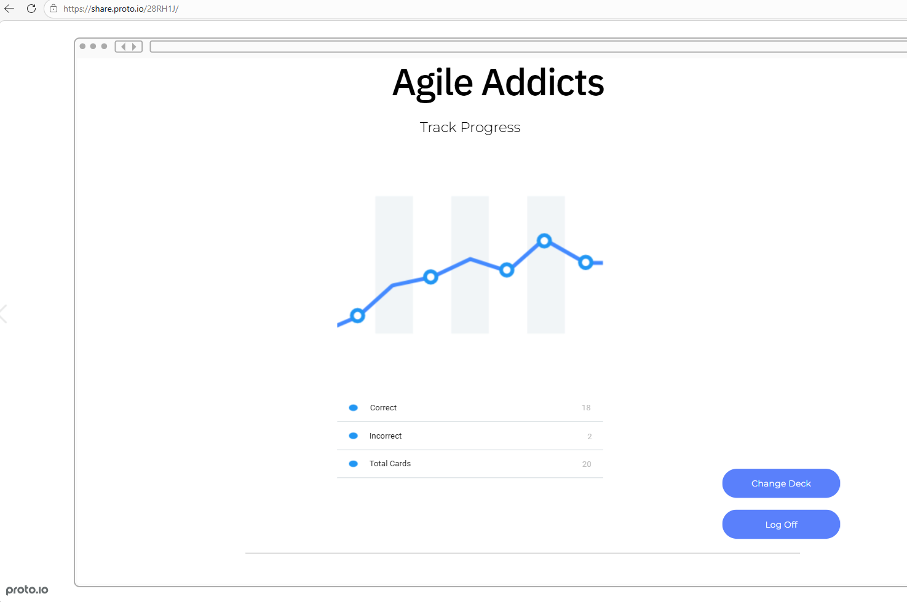
The application displays this interface and allows users view their progress and track past sessions

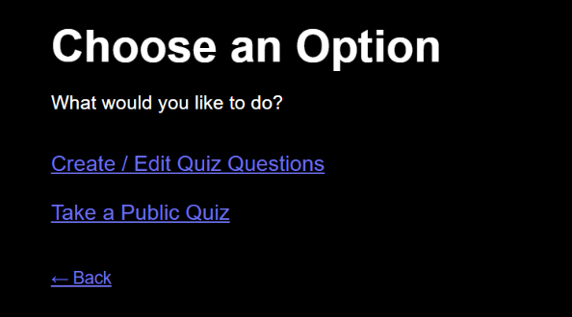
Flashcard Creation Screen
This screen allows users to create new flashcards by entering a question and associating it with a specific quiz (deck).
The interface ensures that required input is collected before proceeding to the next step, supporting validation requirements.
This screen is part of the flashcard creation workflow and contributes to building study material within a deck.
US-5: Create/Edit Flashcard
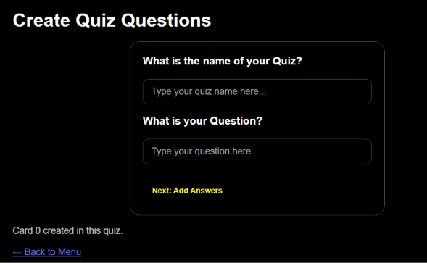

6. Scrum Board
Assigned: Richard Baldwin (Organization Lead)
Backlog entered and Sprint 1 stories/tasks laid out. Confirm instructor has view access.
Scrum Board Link: https://github.com/users/anaylo5450/projects/2
Confirm:
- [Y] Full backlog entered
- [Y] Sprint 1 stories moved to Sprint column
- [Y] Tasks broken down under each story
- [Y] Instructor access confirmed

7. Textbook Connection
The structure of our backlog and overall development approach follows key concepts from the textbook, particularly Agile development and requirements engineering. In Chapter 3, Sommerville explains that Agile focuses on incremental delivery, where “software is developed in increments with the customer specifying the requirements to be included in each increment” (Sommerville p. 80). This is reflected in how we broke our system into user stories (US-1 – US-7) and further into sub-stories that are small enough to be completed within a single sprint.
Our use of Fibonacci story point estimation also aligns with Agile planning practices. Sommerville notes that effort estimation in Agile is relative rather than exact, allowing teams to compare complexity instead of assigning “fixed time periods” (Sommerville p.106). We applied this by assigning Fibonacci values (1, 2, 3, 5, etc.) to each sub-story to represent effort and complexity, while also including rough time estimates for additional context.
Chapter 4 emphasizes the importance of clearly defining system behavior through structured requirements, explaining that “requirements for a software system set out what the system should do and define constraints on its operation and implementation” (Sommerville p.148). It also highlights that requirements must be properly documented and usable, noting that “requirements specification is the process of formally documenting the user and system requirements and creating a software requirements document” (Sommerville p. 149. We applied these ideas by defining preconditions and postconditions for each sub-story, ensuring that every feature is testable and unambiguous. Additionally, our consistent user story formatting (“As a user…” / “As a system…”) aligns with the idea that the requirements document “should be organized so that both system customers and software developers can use it” (Sommerville p.149), helping us clearly capture user needs while still defining system behavior.
Overall, our backlog demonstrates a direct application of Agile and requirements engineering principles by breaking work into small, testable increments, using relative estimation, and clearly defining system behavior.8. Works Cited / AI Assistance Log

8. Works Cited / AI Assistance Log
Assigned: All Members (log your own AI use)

AI Assistance Log
Andrew Naylor - Chat GPT 5 - used to help clarify section 7, thought I was being a bit repetitive. https://chatgpt.com/share/69c810ef-95a0-8330-ae0c-8638e3ee0bd7
Andrew Naylor - This still didn’t do good enough so I gave it another prompt and the textbook , and it finally helped me out https://chatgpt.com/share/69c98b33-c2b4-832f-b11a-8349a1d386d7
Richard Baldwin – Claude Sonnet 4.6 - Used to check work. https://claude.ai/share/e003a73d-3b41-40d4-b555-b17023f9ddb0

Traditional Works Cited
[1] Sommerville, I. (2016). Software Engineering (10th ed.). Pearson.

URL FOR SCRUM CHART:
https://github.com/users/anaylo5450/projects/2

